**Multiplayer Quiz Game**

**1Avinash Kumar, 2Avi Anant, 3Dhanush NJ, 4Avishkar, 5Dr. Nirmala S**

Student1,2,3,4, Prof. 5

Department of Computer Science and Engineering,

AMC Engineering College,

18th K.M. Bannerghatta Main Road, Bengaluru, Karnataka, India – 560083

[Email- 11am24cs030@amceducation.in](mailto:Email-%2011am24cs030@amceducation.in%20) , **2**1am24cs029@amceducation.in, **3**1am24cs061@amceducation.in, **4**1am24cs031@amceducation.in, **5**drnirmala.sundaram@amceducation.in

**ABSCRACT**

This project presents a command-line based Multiplayer Quiz Game developed using Python, aimed at enhancing user engagement through an interactive and educational gameplay experience. The application supports two players who participate in a turn-based quiz format, answering a set of randomly ordered general knowledge questions. Player inputs are processed in real time, with responses evaluated for correctness, and scores updated accordingly. At the conclusion of the quiz, the system compares individual scores and announces the winner, thereby fostering a sense of competition and reinforcing knowledge retention.

The program leverages fundamental programming constructs including loops, conditional statements, string operations, and list manipulation, making it an effective demonstration of problem-solving and logic implementation using Python. Additionally, the use of the random module introduces variability, enhancing replay value. This project serves as an introductory model for interactive text-based applications and lays the groundwork for further development into more advanced multiplayer systems incorporating graphical interfaces and network connectivity.

***KEYWORDS***

***Python Programming, Multiplayer Quiz Game, Command-Line Interface, Turn-Based Game, Randomization, Score Tracking, Educational Game, User Interaction, Logic Implementation, Text-Based Application, General Knowledge, Real-Time Feedback, Programming Constructs, Loops and Conditionals, String Manipulation, JSON File Handling, Terminal-Based Game, Beginner Friendly, Game-Based Learning, Offline Application, Competitive Learning, Gamification in Education, Random Module, Two-Player System, Interactive Learning***

**1. INTRODUCTION**

Today, technology plays a vital role in students learning. Old methods of teaching, like reading from textbooks or listening to lectures, sometimes make students bored or lose focus(1 Educators have started). To solve this problem, learning games have become more popular. These games make learning more fun and help students stay interested. This project is about a Multiplayer Quiz Game made using Python. The game mixes learning and fun .

The game is played by the two players by each got turning answering general knowledge questions. Each correct answer gives the player a point. At the end, the game compares the scores and announces who won. It makes learning feel like a friendly competition, which helps players remember things better and enjoy the process.

It is very easy to use. It runs in a terminal window, which means you don’t need the internet or fancy software. All you need is Python installed on your computer. You type your answers using the keyboard, and the game tells you right away if you were correct. This simple setup is very helpful and especially for people who are just starting to learn programming.

The game uses basic Python features like lists, loops, and if-else conditions to manage questions and answers. It also use the random module to mix up the order of the questions, so the game is different every time you play. This shows how simple tools in Python can be used to build something useful and fun. It's for beginners who wanted to learn coding through small projects.

This game also shows how adding game elements to learning can improve focus and motivation. Many studies say that using the recommended game in the classrooms makes students more excited to learn. Games like this quiz help people think faster, test what they know, and learn from their mistakes(1). This type of learning is more active than just reading or listening.

Even though when current version of that game is simple, it can grow into something bigger. In the future, we could add features like a graphical interface, high score tracking, question categories, or even online multiplayer so friends can play from different places. These updates would make the game more fun and also helped the users to learn more about coding.

In short, this Multiplayer Quiz Game shows how programming could be used for creating a learning tool that was both simple and enjoyable. It teaches coding skills, encourages learning through play, and can be used by students, teachers, or anyone interested in technology. This project proves that you don’t need advanced tools to build something meaningful—just basic knowledge and a good idea.

**2. LITERATURE REVIEW**

1 During the Corona pandemic, Education were forced to shift their teaching methods to online platforms. This transition highlighted a multiple challenges, were around maintaining student engagement and ensuring effective learning in a remote environment. In response to these challenges, a study was conducted to evaluate the impact of game-based digital quizzes on student engagement and learning outcomes. The research specifically focused on comparing the effectiveness of Kahoot!, a gamified quizzing platform, with Google Forms, a more traditional and straightforward tool for administering quizzes(2).

The core motive for study was, determining how digital quizzes affect student engagement, interaction, and learning in online university-level courses. It also sought to compare the usability of gamified versus non-gamified tools and assess whether consistent integration of quizzes into the curriculum would help improve students' learning curves. The study was being done by two major experiments including more than 250 student from a Human-Computer Interaction course. These students were representative of a broader trend in higher education, where keeping learners attentive and involved during virtual sessions became increasingly difficult.

In the first experiment, researchers compared the use of Kahoot! and Google Forms during lectures. Kahoot! was designed with game elements such as time-bound questions, colourful interfaces, leaderboards, and instant feedback. In contrast, Google Forms offered a more neutral, form-based approach without any gamification features. Students participated in quizzes using both platforms, and their levels of engagement, enjoyment, and interactivity were measured. In the second experiment, the researchers integrated Kahoot! quizzes consistently over a period of four months. Students were given pre- and post-tests to measure how their understanding of course material evolved with regular quiz usage.

The results clearly demonstrated the effectiveness of gamified quizzes in enhancing student participation. Students responded very positively to Kahoot!, highlighting it’s fun and interactive elements. They found that the competitive nature of platform, by which the immediate feedback or the rankings, made the process of learning more stimulating and less monotonous. This not just only improvized their motivation to attend and participate in online class but they also helped them retain information better. On the other hand, while Google Forms was thanked for their simplicity and ease of navigation, it lacked the dynamic features that made Kahoot! engaging. Students noted that quizzes on Google Forms felt like routine assessments rather than interactive learning experiences.

In terms of usability, Google Forms was rated higher due to its straightforward layout and fewer distractions. However, when it came to overall engagement and enjoyment, Kahoot! scored significantly better. Most notably, the performance in the academics of the students who regularly participated in Kahoot! quizzes improved substantially. These students showed a 73% gain in their learning outcomes, as opposed to a 57.5% improvement in students who did not do any systematic quiz integration. This difference highlights the value of repeated, interactive practice and feedback in helping students consolidate their knowledge over time.

The study also touches upon the psychological and pedagogical benefits of gamification. Game-based learning tools like Kahoot! introduce elements of challenge, competition, and reward, which can stimulate intrinsic motivation. This is particularly important in online learning environments, where the lack of interaction can result in passive learning behaviours. Gamified quizzes encourage active recall, reinforce key concepts, and promote peer interaction even in virtual settings. These features collectively contribute to deeper cognitive engagement and better academic outcomes.

In conclusion, the research presents strong evidence in favour of integrating game-based quizzes into online education. The findings suggest that tools like Kahoot! not only this just make learning more enjoyable but also moreover it enhances the student engagement, participation, and long-term retention of information. While traditional platforms like Google Forms have their place due to their simplicity and usability, they fall short in creating a stimulating learning atmosphere. Therefore, educators are encouraged to incorporate gamified assessment methods, especially during periods of remote teaching or blended learning, to create more effective and engaging educational experiences. This approach promises for the future of digital education, offering students a more interactive and rewarding learning journey.

2 The research discusses the development and educational significance of an online multiplayer quiz game built using Python. In the era in which the digital tools were increasingly shaping the education system, multiplayer quiz games have emerged as engaging platforms that not just only made the learning more interactive but also help in developing critical thinking, collaboration, and decision-making skills among students. The study emphasizes how such gamified educational tools can enrich the learning process by combining entertainment with pedagogy. These quiz games allow students to participate in real-time competitions with peers, which fosters motivation and deepens understanding of academic content.

With the limitations of traditional teaching methods becoming moreevident—particularly in their ability to sustain attention and promote active participation—educators have started exploring digital alternatives that are more aligned with modern learners' needs. One such solution is integrating multiplayer quiz games into the learning environment. These games encourage real-time interaction, teamwork, and logical thinking, all within a competitive yet supportive atmosphere. As the paper highlights(2), the use of online multiplayer quizzes is not merely for testing knowledge but for promoting meaningful engagement and long-term learning.

Supporting evidence from recent literature adds credibility to the proposal. Studies from 2018 to 2024 have consistently shown the positive impact of multiplayer educational games on student performance. For instance, Efendi (2023) revealed that mobile-based quiz games enhanced critical thinking in sociology students. Likewise, Fatih (2024) demonstrated that augmented reality gameshelped boost science literacy and analytical capabilities. Solikah (2023) found that problem-based learning, when integrated with gaming, not only motivated students but also significantly improved their academic scores. These studies reinforce the idea that multiplayer educational games are effective tools for building cognitive and academic skills.

In response to the problem of declining student engagement in conventional classrooms, the researchers propose a solution in the form of a Python-based multiplayer quiz game. This game is designed to be interactive and educational, supporting features like real-time question battles between players, tracking individual progress, and allowing for flexible use across subjects and difficulty levels. The system is aimed not just at entertainment but at providing teachers with a functional tool to assess and stimulate learning simultaneously.

The development approach for the game follows a structured modular architecture. The design process includes visual diagrams such as flowcharts, data flow diagrams, block diagrams, system architecture,diagrams. These diagrams illustrate how various components such as the quiz engine, scoring system, matchmaking module, and database interact to ensure smooth functioning. This comprehensive design strategy ensures the system is both scalable and adaptable to diverse educational contexts.

Technically, the multiplayer quiz game is implemented using only core Python, with no reliance on external libraries or frameworks. The development begins with defining quiz questions, which are stored in a list or a JSON file. The game operates through a terminal-based interface, where players take turns answering multiple-choice questions. The system evaluates each player's responses, keeps track of scores, and finally declares a winner based on performance. The logic also includes random selection of questions, ensuring a fresh experience in each game session.

The simplicity and accessibility of Python make it an ideal language for creating educational tools like this. By using only the standard input/output capabilities of Python, the game remains lightweight and easy to run on most systems, even without an internet connection. This makes it particularly suitable for classroom use or for learning demonstrations where advanced infrastructure might not be available.

In conclusion, the research showcases a practical and impactful way of leveraging gamification in education. Through the creation of a Python-based multiplayer quiz game, it addresses key challenges in student engagement and cognitive development. The project not only demonstrates technical implementation but also highlights the pedagogical benefits of interactive learning. As digital learning continues to evolve, tools like this have the potential to become integral parts of modern educational strategies, promoting active learning and skill-building in a collaborative and enjoyable manner. and UML class

3The Python-Based Quiz Game project presents a thoughtful solution to modernizing the traditional quiz experience by using programming to make it more interactive, efficient, and scalable. Historically, quizzes were conducted on paper or through verbal questioning, requiring significant time for preparation, manual scoring, and feedback. These traditional methods were not only time-consuming but also prone to human error and lacked interactivity. With the growth in the integration of tech for the field of education and entertainment, thedeveloping for a digital quiz game using Python aims to address these shortcomings by automating the entire process while keeping it engaging and educational.

Python is a popular choice for this type of application due to its simplicity, readability, and the wealth of built-in features. By utilizing Python's basic data structures—such as dictionaries to store questions and answers, lists for sequencing, and sets to track user attempts—the system manages information efficiently. Moreover, with the help of Python's standard libraries like random for question shuffling, time for handling timed responses, and Json for data storage and retrieval, the game becomes both functional and dynamic. The entire application can be run in a terminal without any external dependencies, making it easy to use and accessible for beginners and educators alike.

The project's core objective is to create a basic quiz game that is user-friendly, scalable, and capable of providing instant feedback. It automatically delivers questions to users, validates their answers, tracks scores, and delivers performance summaries. This not only saves time but also makes the learning experience more enjoyable. The application supports functionalities such as timed quizzes, randomized question order, and persistent question banks. This ensures that every session feels fresh and encourages users to think quickly and accurately.

The research behind this project emphasizes the importance of engagement and feedback in learning tools. Compared to commercial platforms like Kahoot and Quizlet, which offer multimedia integration and multiplayer support, this Python-based game is built with simplicity in mind while keeping the core educational objectives intact. It serves as an open-source alternative that can be customized according to specific classroom orpersonal needs. The theoretical framework focuses on leveraging Python’s modular structure, making use of control flows like loops and conditional statements to build the game logic in a clear and organized manner.

Several code examples illustrate how the game operates. The system initializes with a dictionary of questions and allows for dynamic additions to the question bank. Each question is displayed in the terminal, and user input is matched against the correct answer using basic conditionals. Feedback is immediate—correct answers earn points, while incorrect or late responses result in missed opportunities. A variation of the game includes a timed mode where users have a fixed time (e.g., 5 seconds) to respond to each question. This time pressure adds a gamified challenge and mimics real-world testing scenarios.

Another significant feature is the ability to save and load quizzes using the JSON format. This adds persistence to the game, enabling users or educators to reuse the same set of questions across different sessions without manual re-entry. This functionality, paired with simple file handling and exception management, showcases how even basic Python concepts can be used to build practical and reusable applications.

The overall architecture of the game is modular and easy to extend. It’s currently a standalone script but can be scaled up using frameworks like Flask for web-based versions or Tkinter for graphical user interfaces. The design accommodates future upgrades like multiplayer support, multimedia question types, database integration, and user profiles for performance tracking. While the current version is limited to single-user, text-based interactions, it lays a solid foundation for building more complex systems.

The results of the implementation are promising. The system works reliably in presenting questions, validating answers, randomizing content, and enforcing time limits. It demonstrates how fundamental programming concepts can be applied to solve real-world problems in education. Discussions within the report highlight the strengths of the project—such as its simplicity and extensibility—as well as its limitations, like the absence of advanced question types or graphical elements. Recommendations for future work include adding multimedia support, building a web or mobile interface, incorporating a database for better data handling, and enabling multiplayer capabilities using network programming.

In conclusion, the Python-Based Quiz Game successfully meets its goals by transforming manual quiz practices into an engaging digital format. It serves as both an educational tool and a practical demonstration of Python's capabilities. With thoughtful design and future enhancements, this simple yet effective project has the potential to contribute significantly to interactive learning in classrooms and beyond.

4.This outreach project was designed to introduce middle and high school students to the world of computer science through a hands-on programming activity centred around building a basic quiz game using Python. It aimed to increase interest and exposure to programming, particularly for students with little to no prior experience. In California, access to computer science education in schools is limited, with only around 39% of high schools offering any CS courses and just 1% of high school students sitting for the AP Computer Science exam. Given the tech industry's significant presence in California, this gap highlights a pressing need for introductory programs that can spark curiosity and build foundational programming skills among younger students(3).

The initial concept for this outreach activity was a Mad Lib game using Python, chosen because it allows for teaching variables, strings, integers, user input, and string concatenation in a fun and accessible way. Students were introduced to key programming concepts in small, manageable steps using a method called “chunking,” which improves retention by breaking information into digestible parts. The activity was tested first with two junior high students who had some prior exposure to programming. This trial revealed that while the Mad Lib game helped demonstrate basic programming principles, some technical and instructional challenges needed addressing, such as IDE limitations and the pace of delivery(5).

Based on this feedback, the activity was restructured into a new format—a quiz game—which retained the essential programming concepts from the Mad Lib exercise while introducing additional topics like Booleans, conditional statements, and logical operations. This evolution allowed for a more structured learning progression. Students began by learning how to use variables, display messages with print(), gather user input with input(), and then moved on to evaluating user responses using if-else conditions and Booleans. The activity included concept checks and coding exercises that reinforced the difference between assignment (=) and equality comparison (==), which are often confusing for beginners.

The updated quiz game was tested in a high school Algebra 1 class with 25 students, the majority of whom had no prior programming experience. Despite time constraints within the 50-minute session, many students were engaged and worked actively on their projects. There were a few noticeable learning hurdles, particularly with understanding variable behaviour and overwriting values—challenges that aligned with common beginner misconceptions like the “egocentrism bug,” where students assume the computer understands their intent without explicit instructions. These difficulties offered valuable insight into student thought processes and helped refine the teaching strategy further(4).

A follow-up version of the activity was presented as a workshop at Cal Poly’s Kennedy Library, where further modifications were made to improve clarity and usability. Feedback from students suggested that large blocks of instructional text were overwhelming, so the worksheet was reformatted using bullet points and simplified language. Concept checks were added to reinforce key programming principles, especially regarding variable assignment and value updates. While attendance for the workshop was low, the student who participated showed enthusiasm and worked through the material independently, indicating the activity’s accessibility and educational value.

This entire experience highlighted the power of practical, hands-on learning in demystifying programming for beginners. By using relatable examples and gradually introducing new concepts, the activity successfully helped students gain confidence and develop interest in computer science. Several participants reported a newfound willingness to consider taking CS classes or pursuing a degree in the field. The project also helped the instructor realize the value and reward of teaching, and the importance of iterative design in education.

With more time and resources, this activity could be expanded into a multi-day program that covers additional topics and allows for deeper exploration. Improvements such as replacing full code examples with pseudocode, emphasizing common student misconceptions, and enhancing worksheet formatting could make the activity more engaging and effective. The project serves as a promising model for how simple tools like Python can be used to inspire the next generation of computer scientists by making programming accessible, interactive, and fun from the very beginning.

**3. OBJECTIVES**

* Traditional learning tools often lack engagement and interactivity, making it difficult for students to retain general knowledge effectively.

* Many existing quiz games require complex setups, internet connectivity, or advanced user interfaces, limiting accessibility.

* There is a need for a simple, offline-capable quiz game that can be played by multiple users in a competitive and educational manner.

* The solution should be easy to use, require minimal resources, and support real-time score tracking to encourage active participation.

* This project fulfils that need by developing a two-player, text-based quiz game using Python with randomized questions and a turn-based structure.

**4. RESEARCH METHOD**

**Approach**:  
A development-based method was used to build a working multiplayer quiz game using Python, focusing on simplicity, interactivity, and educational value.

**Tools Used**:

* Programming Language: Python
* Interface: Command-Line (Terminal-based)
* Modules: random (for shuffling questions)

**Game Structure**:

* Two-player turn-based quiz
* Players take turns answering shuffled general knowledge questions
* Scores are tracked in real-time and winner announced at the end

**Development Features**:

* Basic Python constructs: loops, conditionals, strings, lists
* Input handled through keyboard; feedback provided instantly
* Lightweight: no GUI, internet, or external libraries required

**Data Handling**:

* Questions stored in a list
* Case-insensitive answer comparison
* Future-ready for JSON integration for question storage

**Scalability**:

* Modular code allows easy upgrades like timers, GUIs (Tkinter), or online play
* Suitable for beginners and educational use

**Ethical Aspects**:

* No personal data is collected
* Safe for classroom or offline educational use

performance and educational value. Instead of relying on complex setups or external tools, we kept things simple and accessible—making it ideal for beginners in programming or education.

**5. FINDINGS**

* Design and develop a lightweight, terminal-based multiplayer quiz game using Python that is simple, accessible, and engaging.
* Build a turn-based system allowing two players to answer questions in alternate turns.
* Utilize the random module to shuffle the question list, offering a unique experience with each playthrough.
* Ensure input validation and compare answers without sensitivity to letter casing for fairness and flexibility.
* Maintain separate score counters for each player to monitor their performance during the game.
* At the end of the quiz, display both players’ final scores and announce the winner. If scores are equal, declare a tie.
* Avoid the need for internet access or graphical user interfaces to keep the game highly portable and user-friendly.
* Aim to provide an enjoyable and educational environment that promotes healthy competition and knowledge growth.

**Block design** 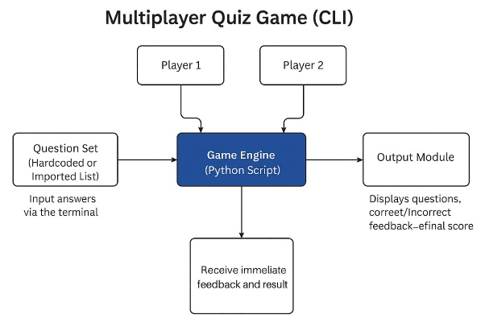

**Fig.5.1**

This project is developed using Python, a high-level, beginner-friendly programming language known for its simplicity and readability. The program is built as a command-line interface (CLI) application, which means it runs entirely in the terminal without the need for graphical components or web browsers. The game uses core Python features such as:

Lists – to store questions and their correct answers

Loops and conditionals – to manage the flow of the game and check user responses

String functions – to compare user answers in a case-insensitive way

Random module – to shuffle the question order each time the game starts

No external libraries, databases, or servers are required, making the game lightweight and fully offline. The program is designed to be easy to run and understand, especially for beginner programmers.

**Architecture design** 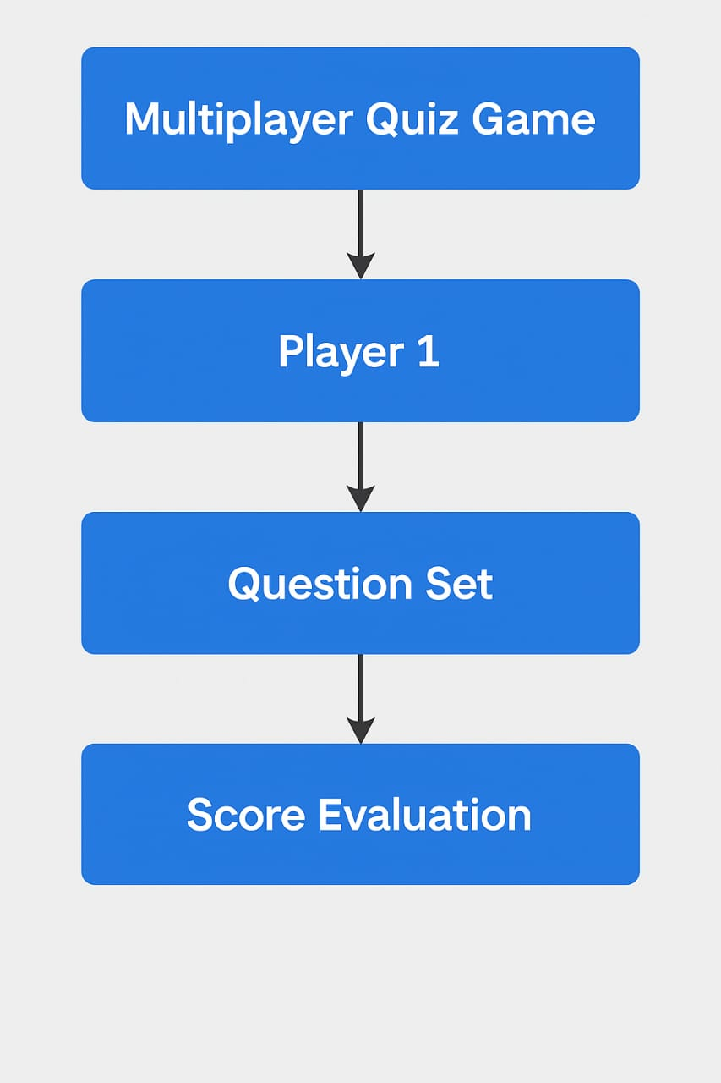

**Fig.5.2**

**6. ANALYSIS**

1. Player Setup:

The game begins by asking two players to enter their names. These names are stored and used throughout the game to personalize the experience.

2. Question Management:

A predefined list of questions and their correct answers is stored in the program. This list is shuffled randomly at the beginning using the random.shuffle() function to ensure that the quiz feels different each time it is played.

3. Turn-Based Gameplay:

The game runs in a loop, asking each player one question at a time. Players take turns answering, and each response is immediately checked against the correct answer.

4. Score Tracking:

ach correct answer adds one point to the player’s score. The program keeps track of both players' scores as the game progresses.

5. Result Display:

After all questions have been answered, the game prints the final scores and announces the winner based on who scored more points. If both players have equal scores, it declares the game a tie.

6. Terminal Interface:

All interaction happens through the terminal, where players input their answers and see the results. No mouse or GUI is needed—just a keyboard and Python installed.

**6.1Implementation**

Below is the complete source code of the Multiplayer Quiz Game developed in Python. The program is designed to run in the command line, allowing two users to answer questions in turns, while automatically tracking their scores and displaying the final outcome.

**6.2Source Code:**

import random

questions = [

("What is the capital of France?", "Paris"),

("How many continents are there?", "7"),

("What currency is used in Japan?", "Yen"),

("Which planet is closest to the sun?", "Mercury"),

("How many legs does a spider have?", "8"),

]

random.shuffle(questions)

score_p1 = 0

score_p2 = 0

print("Welcome to the Multiplayer Quiz Game!")

player1 = input("Enter name for Player 1: ")

player2 = input("Enter name for Player 2: ")

total_questions = 10

for i in range(total_questions):

q, a = questions[i]

if i % 2 == 0:

print(f"\n{player1}, your question:")

answer = input(q + " ").strip()

if answer.lower() == a.lower():

print("Correct!")

score_p1 += 1

else:

print(f"Wrong. The correct answer was: {a}")

else:

print(f"\n{player2}, your question:")

answer = input(q + " ").strip()

if answer.lower() == a.lower():

print("Correct!")

score_p2 += 1

else:

print(f"Wrong. The correct answer was: {a}")

print("\nGame Over!")

print(f"{player1}'s score: {score_p1}")

print(f"{player2}'s score: {score_p2}")

if score_p1 > score_p2:

print(f"{player1} wins!")

elif score_p2 > score_p1:

print(f"{player2} wins!")

else:

print("It's a tie!")

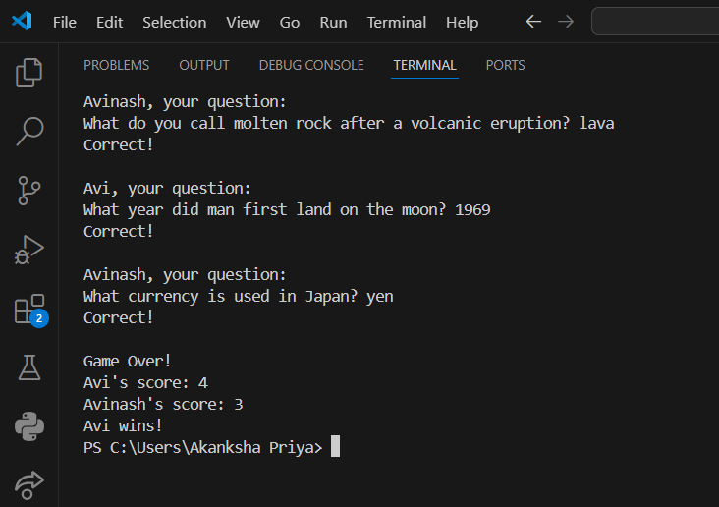**6.3Result:**

**Fig.6.3.1**

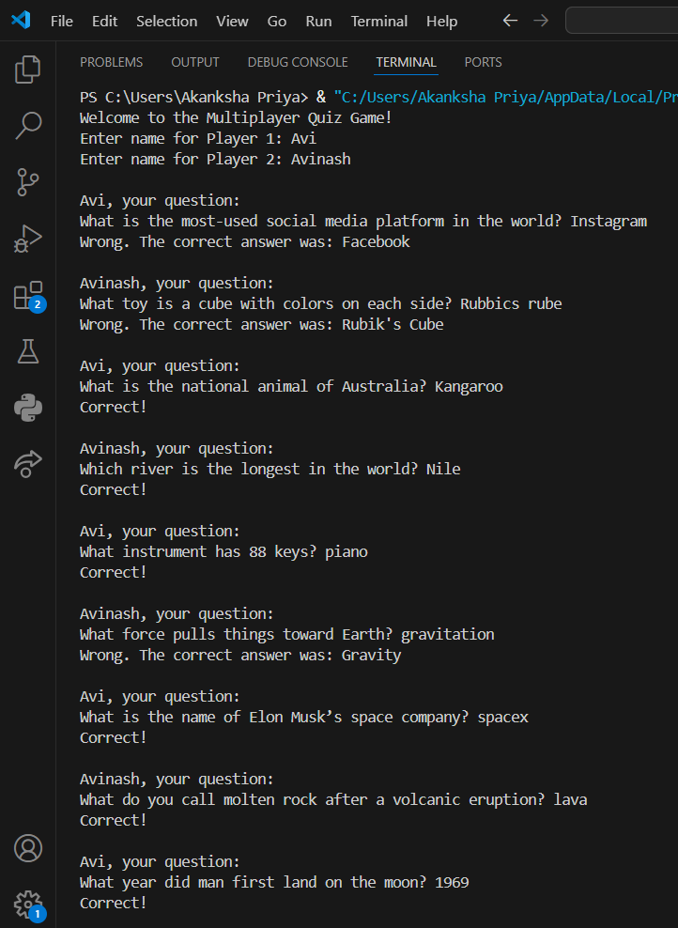

6.3.2**Fig.**

**7.CONCLUSION**

The Multiplayer Quiz Game project effectively showcases how fundamental programming skills can be used to build an engaging and educational application. Created using Python, this game allows two players to take turns answering general knowledge questions. It offers instant feedback, keeps track of scores throughout the game, and declares the winner at the end — all within a simple and intuitive command-line interface.

Designed to make learning enjoyable, the game demonstrates the real-world use of essential programming elements like loops, conditionals, functions, and list-based data management. Since it operates fully offline and doesn't rely on any external libraries, it remains highly accessible and easy to run on most systems. In essence, this project successfully blends education and entertainment while highlighting how basic coding knowledge can lead to the development of interactive and practical applications.

**10.RECOMMENDATIONS**

Although the current version of the Multiplayer Quiz Game is simple and user-friendly, there are several opportunities to enhance its functionality, user engagement, and scalability:

* Expand the Question Bank: Adding more questions will provide greater variety and extend gameplay.
* Introduce Difficulty Levels: Implementing levels such as easy, medium, and hard can accommodate players with different knowledge bases.
* High Score Tracking: Incorporate a system to save and display top scores across multiple sessions.
* Graphical Interface: Developing a GUI using libraries like tkinter or PyQt can make the game more visually engaging and easier to navigate.
* Add Timer for Questions: A countdown timer can add a sense of urgency and increase the game's challenge.
* Single-Player Mode: Enable solo play, either against the clock or a basic AI, to support individual users.
* Topic-Based Questions: Allow players to select specific categories like science, history, or sports to customize their experience.
* Database Support: Use a lightweight database like SQLite to manage questions and scores more efficiently.
* Online Multiplayer Option: Enable networked gameplay using sockets or web-based integration so users can compete remotely.
* Implementing these improvements would not only enhance the overall gaming experience but also introduce more advanced programming techniques, making the project a valuable learning platform for future development.

**REFERENCES:**

**Journal Papers:**

1. (Scott, 2019) — covers computer science access and teaching effectiveness.

2. (Koshy, 2021) — analysis of access to computer science tools.

**Chapters in books:**

3.California Department of Education, 2023— directly relates to California’s K–12 CS standards.

4. (Pea, 1987) — discusses the "buggy path" to programming expertise.

5. (Xie, 2019) — focuses on instruction theory for programming.

6.Krishnamurthi, S. (2019) — Programming Paradigms and Beyond.